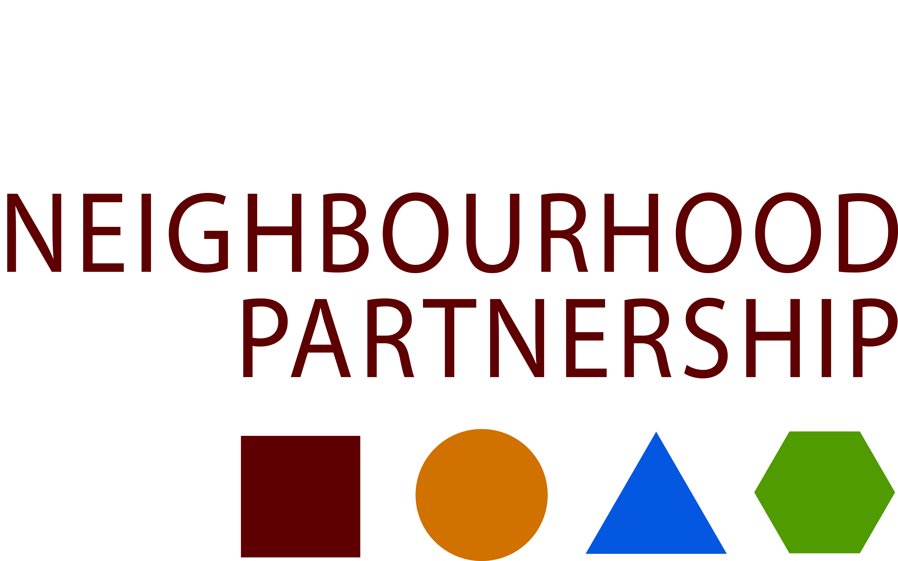
MEET THE FUNDERS !!
Thursday 23 April 2015
1.00 – 4.00pm
The Central Library,George IV Bridge
Edinburgh

Meet the Funders is a free public marketplace event providing access to funding information for community projects. It is an opportunity for groups to discuss their ideas with potential funders and collect a range of information about possible sources of grant aid. No need to book – just drop in.
Free Goodie Bags!

Exhibitors expected include:

﻿Big Lottery  Heritage Lottery Fund | Social Investment Scotland  First Port
The Melting Pot | The Charity Bank
General Enquiries | Business Gateway
Edinburgh4Community | Bank of Scotland Foundation
Pass It On | Registered Tenants Asscn Grants
Community Grants Fund | The Clothworkers Foundation
Sportscotland | Unity Trust Bank
Robertson Trust  Princes Trust Youth Business Scotland  “Yes” Fund  Royal Bank of Scotland Foundation  Lloyds TSB Foundation  Edinburgh Voluntary Organisations Council | Turn 2 Us  CSV Action Earth Grab a Grant  Grow Wild Scotland  Resourcing Scotland’s Heritage  LOOPS Local Opportunities for Older People  Kelly Family Trust
Edinburgh & Lothian Trust Fund
Updated 26/2/15

For more information contact Maureen Thompson maureen.thompson@edinburgh.gov.uk 0131 469 3595

