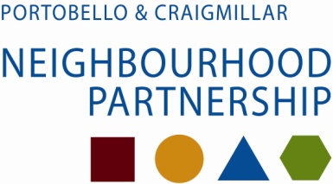

LCP consultation 2014
Target response - 253 Actual - 271

What would your ideal of perfect area look like?
Main themes; safe, clean, and friendly.
Then : green, peaceful, quiet, vibrant and community. Some people did not answer this question.

Would you use these words to describe P&C?
Replies too diverse to analyse: many said some but not all; Portobello ok but not Magdalene/Bingham; not at all: no worse than any other area; getting better; many left unanswered.

Do you agree with EPS top 5 priorities? (Road/traffic improvements; activities for children/YP; dog-fouling; clean up area; better or affordable housing)
Most (75%) agreed that these were the top 5 priorities.

Have we missed anything important?
Most also said we had left something out: anti-social behaviour: tidy streets; parking; activities for young people; dog-fouling, roads.

Choose one single issue
Most popular were: activities for young people, clean- up area, dog-fouling; safety, housing; schools.

Portobello CC consultation
Around 100 people responded to a PCC consultation. When asked about what they liked living in Portobello 4 main themes arose:
Community Spirit; Parks/Prom Open Space; Location; Local Shops/High Street.
When asked what they thought could be changed to improve Portobello 4 themes arose:
Less litter and dog-mess; Traffic congestion improved; new High School; better local shops.

Police Plan - policing priorities for the Craigmillar / Portobello area were
- Antisocial Behaviour
- Housebreaking and other Theft
- Drug Dealing and Drug Abuse
- Assault and Violent Crime

