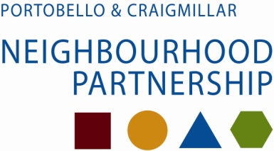

Late CGF applications
Since the Agenda Planning and Business Meeting we have received three new applications.
The Jack Kane Centre has applied for £1,250 to provide “5 dirty dancing events” for an average of 70 older people at each one. The events would be dispersed throughout the year to combat feelings of social isolation. The funds will be to cover the cost of publicity, transport, entertainment and light refreshments. The Management Committee have raised an £244 towards this, and report that a further £490 will be supplied from CLD and the Jack Kane Centre in “in-kind” contributions to cover room hire and the design cost for stationary.
This application meets the priority of promoting activities which help people stay well by being involved in social or community networks. The applicant received the same amount in the last two years, £750 in 2011, and £500 in 2010 for similar activities.

Carr Gorm Community Compass has applied for £1,272 to pay Edinburgh Community Food to run a 6 week basic cooking course for 8 isolated single men over 40 in Craigmillar (£660), and to buy 10 helmets, bike locks and Hi-Vis waistcoats to allow a cycling group of adults to operate (£430). The balance of £182 would provide thermos jugs, mugs and 2 rucksacks.

This application meets the of promoting activities which help people stay well by being involved in social or community networks and promotes healthy eating and exercise. The applicant has not applied for a Community Grant from this partnership before.

Bridgend Growing Communities has applied for £1,450 to offer opportunities for children from Craigmillar to learn about the link between growing fruit and vegetables and healthy eating and to gain basic growing skills. The programme will be
- One 3 hour session at Bridgend to learn growing skills and have a healthy meal with produce grown there;
- Two 90 minute sessions at the school, nursery or children’s centre where the children will share this knowledge with their class; and
- One 2 hour follow-up family session at Bridgend when children acan bring their families on a visit.
Ten programmes will be held for different children, amounting to 100 children altogether. The funding breakdown is £100 for materials, £100 for refreshments and food, £1,200 for sessional staff and £50 for travel costs. BGC is a voluntary organisation and does not employ any staff.
The applicant has consulted with Castleview Primary, Castleview Community Centre and the Public Health Practitioner.
This application meets the of promoting activities which help people stay well by being involved in social or community networks and promotes healthy eating and exercise. The applicant has not made any application previously.

The recommendations from the Business Meeting amount to £5,066, the application from Commonwealth Theatre already circulated is £2,540, and the three here amount to £3,972. The allocation is £21,737.

