CONSTITUTION – PORTOBELLO COMMUNITY COUNCIL

1. Name

The name of the COMMUNITY COUNCIL shall be Portobello Community Council (referred to as “the COMMUNITY COUNCIL” in this document).

2. Area of the Community Council

The area of the COMMUNITY COUNCIL shall be as shown on the map attached to the local authority’s Scheme for the Establishment of Community Councils.
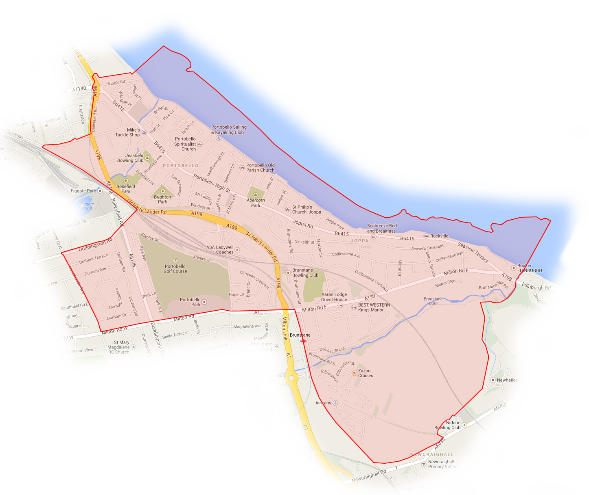
3. Objectives

The objectives of the COMMUNITY COUNCIL shall be:

(a) to ascertain, co-ordinate and reflect the views of the community which it represents, to liaise with other community groups within the area, and to fairly express the diversity of opinions and outlooks of the people;

(b) to express the views of the community to the local authority for the area, to public authorities and other organisations;

(c) to take such action in the interests of the community as appears to it to be desirable and practicable;

(d) to promote the well-being of the community and to foster a community spirit;

(e) to be a means whereby the people of the area shall be able to voice their opinions on any matter affecting their lives, their welfare, their environment, its development and amenity.

4. Role and Responsibilities

In the discharge of their functions and the conduct of their business, the COMMUNITY COUNCIL and its membership shall have regard to their role and responsibilities as set out in paragraph 3 of the Scheme for Community Councils, approved by the local authority; and the Community Councils’ Code of Conduct.

5. Membership

The COMMUNITY COUNCIL’S membership is as governed by paragraph 5 of the Scheme; and as determined from time to time by the City Council.

6. Method of Election

Election procedures shall be governed by the method of election laid down in section 6 of the Scheme.

7. Casual Vacancies on the Community Council

Where, a vacancy arises which does not result in the number of COMMUNITY COUNCIL members falling below the minimum number as specified in paragraph 5 of the Scheme, the COMMUNITY COUNCIL may, if it considers it to be desirable, agree to:-

(a) an extraordinary general meeting be held in order that the vacancy (and any other outstanding vacancies) can be filled, on the basis that such vacancies would be publicised, nominations invited and an election held where the number of candidates exceeded the number of places available. Such interim elections will be administered with guidance from the local authority.

(b) the filling of a vacancy by co-option with voting rights to a maximum of one third of the total membership of the community council as governed by paragraph 6 of the Scheme.

Co-opted representatives may be appointed by the passing of a motion to that effect at a community council meeting , proposed and seconded by other elected and nominated members of the community council.

(c) the vacancy to be left unfilled until local public interest is expressed or until the next set of regular elections.

8. Voting Rights of Members of the Community Council

The right to vote at any meeting of the COMMUNITY COUNCIL or any committee thereof, shall be held by all COMMUNITY COUNCIL members whether elected, nominated or co-opted, except those associate members co-opted for specific issues on a temporary basis, or ex-officio members. With the exception of circumstances which may arise under the Scheme for Community Councils: Clause 6 – Community Council Elections [Co-option]; and Constitution: Clause 16 – Alterations to the Constitution and Clause 17 – Dissolution, all decisions of the COMMUNITY COUNCIL will be decided by a simple majority of those eligible to vote and present and voting.

In the event of a vote of the community councillors that results in a majority not being achieved, the chairperson shall have a casting vote.

9. Election of Office-Bearers

(a) At the first meeting of the COMMUNITY COUNCIL after elections in the year when elections are held and at the Annual General Meeting in May or June in the year when elections are not held, the COMMUNITY COUNCIL shall appoint a Chair, Secretary, Treasurer and such other office-bearers as it shall from time to time decide.

(b) All office-bearers shall be elected for one year, but shall be eligible for re-election, without limitation of time.

(c) Without the express approval of the local authority, a member shall hold no more than two of the following offices at any one time: Chairperson, Secretary or Treasurer and shall not hold office in more than one community council.

Community councils may appoint employees from time to time provided that no member of a community council shall hold any paid office.

Community councils may reimburse office bearers, other members and employees for any reasonable expenses incurred in the performance of their duties.

10. Committees of the Community Council

The COMMUNITY COUNCIL may appoint representatives to committees of the COMMUNITY COUNCIL; and shall determine their composition, terms of reference, duration, duties and powers.

11. Meetings of the Community Council

(a) The quorum for COMMUNITY COUNCIL meetings shall be at least one third of the current eligible voting membership, or 3 eligible voting members, whichever is the greater.

(b) Once in each year in the month of May or June the COMMUNITY COUNCIL shall convene an annual general meeting for the purpose of receiving and considering the annual report of the COMMUNITY COUNCIL, the appointment of office bearers, and the submission of the independently examined annual statement of accounts.

(c) Including the annual general meeting, the COMMUNITY COUNCIL shall meet not less than 7 times throughout the year.

- Dates, times and venues of regular meetings of the COMMUNITY COUNCIL shall be fixed at the first meeting of the COMMUNITY COUNCIL following ordinary elections and thereafter at its annual general meeting. Special meetings shall require at least 10 days public notice, either called by the Chairperson, or on the request of not less than one-half of the total number of COMMUNITY COUNCIL members. An officer of the local authority has the discretion to call a meeting of the COMMUNITY COUNCIL.

(e) Copies of all minutes of meetings of the COMMUNITY COUNCIL and of committees thereof shall be approved at the next prescribed meeting of the COMMUNITY COUNCIL, but the draft minute shall be circulated at least 7 days before the date of the meeting, to COMMUNITY COUNCIL members and the local authority’s liaison officer for COMMUNITY COUNCILS.

- The COMMUNITY COUNCIL shall abide by its standing orders for the proper conduct of its meetings.

- The COMMUNITY COUNCIL has a duty to be responsive to the community it represents. Should the COMMUNITY COUNCIL receive a common written request (petition), signed by at least 20 persons resident within the COMMUNITY COUNCIL area to convene a special meeting for a particular matter or matters to be debated, it shall hold such a meeting, within 21 days of receipt of such a request and advertise it in the manner prescribed locally for special meetings called by the COMMUNITY COUNCIL.

- The COMMUNITY COUNCIL can meet to discuss items of business in private where it considers it appropriate to do so. The decision to meet in private will be agreed in advance and decided by a majority vote. Notice of such a meeting will be given to the public in the usual way. However, the Notice will record that the meeting, or a part thereof, shall be held in private.

12. Public Participation in the Work of the Community Council

(a) All meetings of the COMMUNITY COUNCIL and its committees (subject to 11(h), above) shall be open to members of the public. Proper provision is to be made for the accommodation of members of the public and the opportunity should be afforded at each meeting to permit members of the public to address the COMMUNITY COUNCIL, under the guidance of the Chairperson.

(b) Notices calling meetings of the COMMUNITY COUNCIL and its committees shall be posted prominently within the COMMUNITY COUNCIL area before the date of any such meeting, and, where possible, be advertised by other suitable means.

13. Information to the Local Authority

The local authority’s liaison officer shall be sent an annual calendar of the COMMUNITY COUNCIL’S prescribed meeting dates, times and venues, which should be agreed at the COMMUNITY COUNCIL’S annual general meeting; minutes of all meetings, the annual report, the annual financial statement and any other such suitable information, as may from time to time be agreed between the COMMUNITY COUNCIL and the local authority. When special meetings of the COMMUNITY COUNCIL are to be held, the local authority’s liaison officer should be advised of the date, time venue and subject(s) of debate of such meetings, at least 10 days in advance of the meeting date.

14. Control of Finance

(a) All monies raised by or on behalf of the COMMUNITY COUNCIL or provided by the local authority and other sources shall be applied to further the objectives of the COMMUNITY COUNCIL and for no other purpose. The monies provided by the local authority in the annual Administrative Grant for administrative and other approved purposes shall be used only as prescribed. Monies raised from other sources may be used in accordance with the terms of this provision (so long as they are consistent with the objectives of the community council), or in the absence of such terms, for the furtherance of the objectives of the COMMUNITY COUNCIL.

- The treasurer shall undertake to keep proper accounts of the finances of the community council.

(c) Any two of three authorised signatories, who must be office-bearers of the community council, may sign cheques on behalf of the COMMUNITY COUNCIL. Authorised signatories may not be co-habitees.

(d) A statement of accounts for the last financial year, independently examined by an examiner appointed by the COMMUNITY COUNCIL, who is not a member of the COMMUNITY COUNCIL, shall be submitted to an annual general meeting of the COMMUNITY COUNCIL and shall be available for inspection at a convenient location.

- The financial year of the COMMUNITY COUNCIL shall be from (1 April) until (31 March) the succeeding year. Examined accounts as received and approved by the COMMUNITY COUNCIL at the annual general meeting shall be submitted to the local authority following approval at the community council’s annual general meeting.
15. Title to Property

Property and other assets belonging to the COMMUNITY COUNCIL shall be vested in the Chair, Secretary and Treasurer of the COMMUNITY COUNCIL and their successors in these respective offices.

16. Alterations to the Constitution

Any proposal by the COMMUNITY COUNCIL to alter this Constitution must be first considered by a meeting of the COMMUNITY COUNCIL and the terms of the proposed resolution to alter the Constitution shall be stated on the notice calling the meeting which shall be issued not less than ten days prior to the meeting. Any proposed alterations may not prejudice the terms and objectives contained within the local Scheme of Community Councils.

If the resolution is supported by two-thirds of the total voting membership of the COMMUNITY COUNCIL and is approved in writing by the local authority or its appointed officer, the alteration shall be deemed to have been duly authorised.

17. Dissolution

If the COMMUNITY COUNCIL by a two-thirds majority of the total voting membership decides at any time that it is necessary or advisable to dissolve, it shall agree a date for a public meeting to be held to discuss the proposed resolution to dissolve. It is a requirement that not less than ten days prior to the date of such meeting a public notice be given by means of notification in the local newspaper. If the resolution is supported by a majority of those persons present and qualified to vote and is approved by the local authority, the COMMUNITY COUNCIL shall be deemed to be dissolved and all assets remaining, subject to the approval of the local authority, after the satisfaction of any proper debts or liabilities shall transfer to the local authority who shall hold same in Trust for a future COMMUNITY COUNCIL representing that area.

In the event that the COMMUNITY COUNCIL is dissolved under the above procedure, and twenty or more electors subsequently wish the re-establishment of a COMMUNITY COUNCIL for the area, these electors shall submit a requisition to the local authority in accordance with Section 52(7) of the Local Government (Scotland) Act 1973, on receipt of which the Returning Officer shall arrange for elections to be held in accordance with the Scheme for the Establishment of Community Councils.

Where for any reason, the number of COMMUNITY COUNCIL members falls below the minimum specified in the Scheme for the Establishment of Community Councils the local authority may, by suspending the Constitution of the COMMUNITY COUNCIL, cause the COMMUNITY COUNCIL to be dissolved and in this event, the procedures for the establishment of a new COMMUNITY COUNCIL being those identified in the immediately preceding paragraph hereof, shall be initiated.

18. Approval and adoption of the Constitution

This Constitution was adopted by Portobello Community Council, on

...................................................................

Signed: Chairman
.........................................................

......................................................... Member

......................................................... Member

......................................................... Date

and was approved on behalf of …………………………..……….. Council on

.........................................................

......................................................... Signed

......................................................... Date

Based on “MODEL CONSTITUTION FOR COMMUNITY COUNCUILS 2013.docx” supplied by Edinburgh Council 14 Nov 2013 with no changes except substitution of “Portobello Community Council” where appropriate and insertion of overview map.

